# Assignment 3

*Rui Qin 30874157*

## Task A

We first enter the folder which contains the Task A data file.

cd C:

cd A3/TaskA

### 1)

We using tar -xf to decompress the tar file

tar -xf dataset_TIST2015.tar

Then we list the document with ‘ls’

$ ls

dataset_TIST2015.tar dataset_TIST2015_POIs.txt

dataset_TIST2015_Checkins_v2.txt dataset_TIST2015_readme_v2.txt

dataset_TIST2015_Cities.txt

There are **4 txt files** in the tar. Now we can check the size of them with -lh, it will print the size and time it created.

Qr140@AllEN /cygdrive/c/A3/TaskA

$ ls -lh dataset_TIST2015_POIs.txt

-rwxrwxr-x+ 1 Qr140 Qr140 222M Aug 12 2015 dataset_TIST2015_POIs.txt

Qr140@AllEN /cygdrive/c/A3/TaskA

$ ls -lh dataset_TIST2015_Checkins_v2.txt

-rwxrwxr-x+ 1 Qr140 Qr140 2.1G Oct 6 21:53 dataset_TIST2015_Checkins_v2.txt

Qr140@AllEN /cygdrive/c/A3/TaskA

$ ls -lh dataset_TIST2015_readme_v2.txt

-rwxrwxr-x+ 1 Qr140 Qr140 2.0K Oct 6 21:59 dataset_TIST2015_readme_v2.txt

Qr140@AllEN /cygdrive/c/A3/TaskA

$ ls -lh dataset_TIST2015_Cities.txt

-rwxrwxr-x+ 1 Qr140 Qr140 25K Aug 13 2015 dataset_TIST2015_Cities.txt

Based on the code we can know:

* dataset_TIST2015_POIs.txt is **222MB**
* dataset_TIST2015_Checkins_v2.txt is **2.1GB**
* dataset_TIST2015_readme_v2.txt is **2KB**
* dataset_TIST2015_Cities.txt is **25KB**

### 2)

In this part we can use:

$ head -1 dataset_TIST2015_Checkins_v2.txt | less

To check how many columns and what is the delimiter. The output is:

user_id venue_id UTC_time timezone_offset

There are **4 columns** in this data frame. Then we use the search function with tab (/^I):

user_id venue_id UTC_time timezone_offset

50756 4f5e3a72e4b053fd6a4313f6 Tue Apr 03 18:00:06 +0000 2012 240

190571 4b4b87b5f964a5204a9f26e3 Tue Apr 03 18:00:07 +0000 2012 180

221021 4a85b1b3f964a520eefe1fe3 Tue Apr 03 18:00:08 +0000 2012 -240

66981 4b4606f2f964a520751426e3 Tue Apr 03 18:00:08 +0000 2012 -300

All the spaces are filled with the highlight, which means the delimiter is **tab.**

### 3)

We can use the part 2 code to list out all columns:

$ head -1 dataset_TIST2015_Checkins_v2.txt | less

output is:

user_id venue_id UTC_time timezone_offset

We can conclude the column name is:

* user_id
* venue_id
* UTC_time
* timezone_offset

### 4)

In this part we can use awk, sort, uniq with word count to calculate how many unique user values are in the file, and due to the delimiter is the tab, so we use -F ‘\t’ after awk.

$ awk -F '\t' '{print $1}' dataset_TIST2015_Checkins_v2.txt | sort | uniq | wc -l

266910

Due to *user_id* can be counted as 1 in that column. so after subtracting 1, we can know there are **266909** unique users in this file.

Then we can use wc -l to check how many lines are in the file, and get the number of check-in.

$ wc -l dataset_TIST2015_Checkins_v2.txt

33263634 dataset_TIST2015_Checkins_v2.txt

Due to the title being counted in, so we have to subtract it with 1. We can see there are 33263633 checkin records.

### 5)

We can use *head -n2* to get extract the second line which starts counting from the head (The first line is the title). We want to get the time, so we know the information we want is from column 3.

$ awk -F '\t' '{print $3}' dataset_TIST2015_Checkins_v2.txt | head -n1

UTC_time

Tue Apr 03 18:00:06 +0000 2012

We can see the first date is **Tue Apr 03 18:00:06 +0000 2012**

Then we extract the first line from the tail to get the last time

$ awk -F '\t' '{print $3}' dataset_TIST2015_Checkins_v2.txt | tail -n1

Mon Sep 16 23:24:15 +0000 2013

We can know the last date is **Mon Sep 16 23:24:15 +0000 2013**

### 6)

We can use the part 4 method to get the number of unique.

Qr140@AllEN /cygdrive/c/A3/TaskA

$ awk -F '\t' '{print $1}' dataset_TIST2015_POIs.txt | sort | uniq | wc -l

3680126

Qr140@AllEN /cygdrive/c/A3/TaskA

$ awk -F '\t' '{print $1}' dataset_TIST2015_POIs.txt | head -n1

3fd66200f964a52000e71ee3

We can see that there are **3680126** records, and the first row is not the title so we don't need to subtract one from the total.

### 7)

In this case, we can search the lines which are column 5 only contain FR with the condition **$5== "FR"**, and then we use cut -f 4 to cut the categories column.In the end, we use **sort** and **uniq** to make sure the lines are unique.

$ awk -F '\t' ' $5 == "FR" ' dataset_TIST2015_POIs.txt | cut -f 4 |sort | uniq | wc -l

384

Then we can get there are **384** unique venue categories including France,

### 8)

#### a)

We can know the Europe land area can be defined in the range 34° to 72° latitude and -25° to 45° longitude (European, 2020), and the readme points out that **the second column is latitude and third column is longitude**. We can base on this information to sort the data which contain European.

In this code, we sort columns 2 and 3 by using the conditions, and connect the condition with && which means AND in shell, then output the data in POIeu.txt.

$ (awk -F '\t' '$2 >= 34 && $2 <= 72 && $3 >= -25 && $3 <= 45' dataset_TIST2015_POIs.txt) > POIeu.txt

#### b)

Explanation of this part:

* **{arr[$5]++}**

increment array with column 5 as the key

* **END{for (element in arr) print element, arr[element]}**

The block executed at the end

* + In the block, we create a for loop and go through the elements in the array
  + Print the lines
    - Print the element first
    - Print the count number in the array, with the element as key
* **sort -k2 -n**

Sort the printout data

* + -k2 means we sort column 2 data
  + -n means we use a numeric sort

$ awk -F "\t" '{arr[$5]++}END{for (element in arr) print element, arr[element]}' POIeu.txt | sort -k2 -n

LB 63

EE 2170

BG 2411

DK 2735

CH 2930

TN 3598

PL 3651

RO 3858

IE 3968

AT 5636

FI 5651

CZ 5707

SE 6389

BY 6693

CY 6804

LV 7924

HU 8681

PT 8721

GR 18259

FR 19837

UA 29276

IT 34332

DE 34713

BE 36826

NL 38536

ES 39187

GB 54278

RU 157378

TR 377302

Based on the output list, we can know **TR has the most venues and LB has the least**

#### c)

In this case what we need to do is add **$4 == "Seafood Restaurant"** before the **{arr[$5]++}**. In this way, we can firstly sort out the seafood restaurant, and then process our rest code.

awk -F '\t' '$4 == "Seafood Restaurant" {arr[$5]++}END{for (element in arr) print element, arr[element]}' POIeu.txt | sort -k2 -n

PL 1

BY 2

CH 2

EE 2

FI 2

LB 3

LV 5

BG 6

CZ 6

DK 6

HU 6

RO 6

IE 7

TN 11

SE 15

AT 16

CY 25

UA 26

FR 39

PT 57

BE 63

RU 64

DE 76

NL 94

GB 108

GR 110

ES 123

IT 134

TR 1522

Based on the result, we can know **TR has the most seafood restaurants** in their country.

#### d)

We first using index function to create the condition: string include ‘Restaurant’ and put it at the front. In this case, we need to use the old method but with a change. We need to put frequency before the restaurant list because the length of the restaurant name is different.

So **arr[element]** is in front of the **element**, which means we print the frequency first and then print the restaurant name. Then we sort the first column with **-k1**.

$ awk -F '\t' ' index($4, "Restaurant") {arr[$4]++}END{for (element in arr) print arr[element], element }' POIeu.txt | sort -k1 -n

23 Filipino Restaurant

27 Mongolian Restaurant

37 Peruvian Restaurant

51 Gluten-free Restaurant

53 Malaysian Restaurant

54 New American Restaurant

57 Southern / Soul Food Restaurant

67 Australian Restaurant

67 Indonesian Restaurant

72 Cajun / Creole Restaurant

77 Ethiopian Restaurant

89 South American Restaurant

95 Cuban Restaurant

95 Latin American Restaurant

96 Dim Sum Restaurant

126 Molecular Gastronomy Restaurant

130 Dumpling Restaurant

130 Paella Restaurant

137 Caribbean Restaurant

137 Swiss Restaurant

150 Moroccan Restaurant

179 Afghan Restaurant

181 Arepa Restaurant

185 Brazilian Restaurant

207 Korean Restaurant

313 Argentinian Restaurant

322 African Restaurant

326 Scandinavian Restaurant

338 Vietnamese Restaurant

422 Portuguese Restaurant

522 Vegetarian / Vegan Restaurant

580 Falafel Restaurant

754 Thai Restaurant

759 Mexican Restaurant

1096 German Restaurant

1292 American Restaurant

1371 Indian Restaurant

1456 Tapas Restaurant

1507 Greek Restaurant

1689 Eastern European Restaurant

1755 Japanese Restaurant

1911 Spanish Restaurant

2077 Mediterranean Restaurant

2124 Sushi Restaurant

2219 Chinese Restaurant

2414 Asian Restaurant

2537 Seafood Restaurant

2716 Middle Eastern Restaurant

2863 French Restaurant

7666 Italian Restaurant

8634 Fast Food Restaurant

10093 Turkish Restaurant

15208 Restaurant

Based on the result, we can know the most common restaurant is **Restaurant with no categories**, and the most common restaurant with the category is **Turkish restaurant**.

**Reference in case 8:**

European, Environment, Agency. (2020). *Global and European temperatures*. [Global and European temperatures — European Environment Agency (europa.eu)](https://www.eea.europa.eu/data-and-maps/indicators/global-and-european-temperature-10#:~:text=Europe%20is%20defined%20here%20as,to%2045%C2%B0%20eastern%20longitude.)

## Task B

To unzip the .gz file we use gunzip.

$ gunzip Twitter_Data_1.gz

And we get a view of the data

head -n1 Twitter_Data_1

433213478539513856 TRY_Sound Tue Feb 11 12:18:36 +0000 2014 またたび食べると一時的に楽しくなるし、血行良くなるから頭痛も無くなるけど、覚めた後死ぬ。が食べる。うまい

This result suggests that:

* The data frame does not have the header
* The data looks like the record of a Twitter post
* We can assume:
  + The first part is ID
  + The second part is the name of the user
  + The third part is time
  + The fourth part is content

Then we find the delimiter, with the search up function **(/^I).**

head -1 Twitter_Data_1 | less

433213478539513856 TRY_Sound Tue Feb 11 12:18:36 +0000 2014 またたび食べると一時的に楽しくなるし、血行良くなるから頭痛も無くなるけど、覚めた後死ぬ。が食べる。うまい

The delimiter is the **tab**.

### 1)

Based on the requirement, we can use grep to extract the word ‘Donald Trump’. **-oi** means ignore case sensitivity and display only the matched string in the next line.

$ awk -F '\t' '{print $4}' Twitter_Data_1 | grep -oi "Donald Trump" | wc -l

130

Donald Trump appears about **130** times in the data set.

### 2)

The system begins with ignore case setting with **BEGIN{IGNORECASE=1},** then we use the method in task A part 8.

(awk -F '\t' ' BEGIN{IGNORECASE=1} index($4, "Donald Trump") ' Twitter_Data_1) > Donald.txt

After we create a data set we have to verify our data set has the correct amount of ‘Donald Trump’.

$ awk -F '\t' '{print $4}' Donald.txt | grep -oi "Donald Trump" | wc -l

130

The number of “Donald Trump” is the same as in part 1. We can start extracting the time column and output it as .csv, then add the header to the column with the sed method.

* -i means edit file
* -e means the script in command will be executed
* 1i means insert before line 1

awk -F '\t' '{print $3}' Donald.txt > Donald.csv

sed -i -e ' 1i"date"' Donald.csv

Now we can start analysing the data with R language.

Initial our R environment and check the data type

* We using ggplot in this assignment
* **rm(list=ls())** is used to clean the R environment
* Set working directory as TaskB
* Using read.csv to read csv file
* Str() can display the data type of column

library(ggplot2)

#read data

rm(list = ls())

setwd("C:/A3/TaskB")

df <- read.csv("Donald.csv")

str(df)

**output:**

'data.frame': 122 obs. of 1 variable:

$ date: chr "Tue Feb 11 12:28:36 +0000 2014" "Tue Feb 11 12:47:26 +0000 2014" "Tue Feb 11 12:55:09 +0000 2014" "Tue Feb 11 13:22:29 +0000 2014" ...

The data type of date is the character, we have to turn it into date time. In this case, we use striptime with a format based on the time’s data, and we set the time zone in GMT then replace data in the column.

After using striptime, the data type is POSIXlt, and we need to turn it to POSIXct for making graph. So we use as.POSIXct() to turn it into the data type we want.

#turn date from char to date

df[['date']]<-strptime(df[['date']],

format = "%a %b %e %H:%M:%S %z %Y",

tz = "GMT")

df[['date']]<-as.POSIXct(df[['date']])

str(df)

**output:**

'data.frame': 122 obs. of 1 variable:

$ date: POSIXct, format: "2014-02-11 12:28:36" "2014-02-11 12:47:26"

After the process, we can get the date data in POSIXct format.

### 3)

Plot the previous data with ggplot2, and set the plot title, x-axis and y -axis title wth labs. Using geom_histogram to let ggplot plot a histogram and set the bins as 100.

ggplot(df,

aes(x=date)) +

labs(

title = "Post over the time",

x = "Time",

y = "Post Count")+

geom_histogram(bins = 100,

fill="#69b3a2",

color="#e9ecef",

alpha=0.9)

Then we can get the histogram of posts over the time

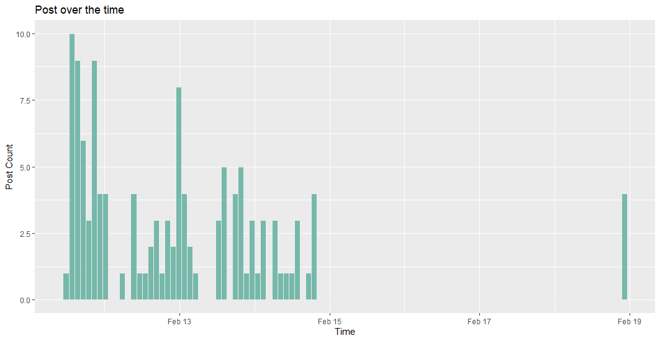

### 4)

Based on the graph we can know:

* The data shows the **positive skewed bimodal distribution**
  + This suggests that before Feb 15, the number of posts reaches its highest point (10 posts) at midnight of Feb 11 and then drops to the bottom at day time of Feb 12. But on Feb 13, the number of posts goes up and then slowly goes down to 0.
  + After Feb 15, there is a little post (around 4 posts) on the night of Feb 18
  + User activity is higher during the day to 1 midnight the next day, with activity highest in the middle of the night.
  + The trend of Trump has been hot for about 3 days.

### 5)

Before we start our analysis, we prepare our dataset. We use the method in Task A case 8, but we add a comma between the element and count, then output as CSV. And then we add a header in our CSV file.

$ awk -F '\t' ' {arr[$2]++}END{for (element in arr) print arr[element], "," ,element }' Twitter_Data_1 | sort -k1 -n > user.csv

$ sed -i -e ' 1i"count","user"' user.csv

Then we can input the CSV file in R and check the datatype of the column.

df2 <- read.csv("user.csv")

str(df2)

**output:**

'data.frame': 8977904 obs. of 2 variables:

$ count: num 1 1 1 1 1 1 1 1 1 1 ...

$ user : chr " " " 000000000003737" " 0000000000_24" " 0000000000yours" ...

We can see the column ‘count’ is a number and the ‘user’ is a character. Then we plot the histogram of the distribution of tweets.

p = ggplot(df2,

aes(x=count)) +

labs(

title = "Distribution of the number of Tweets",

x = "Post Count",

y = " Account Count")+

geom_histogram(bins = 100,

fill="#69b3a2",

color="#e9ecef",

alpha=0.9)

p

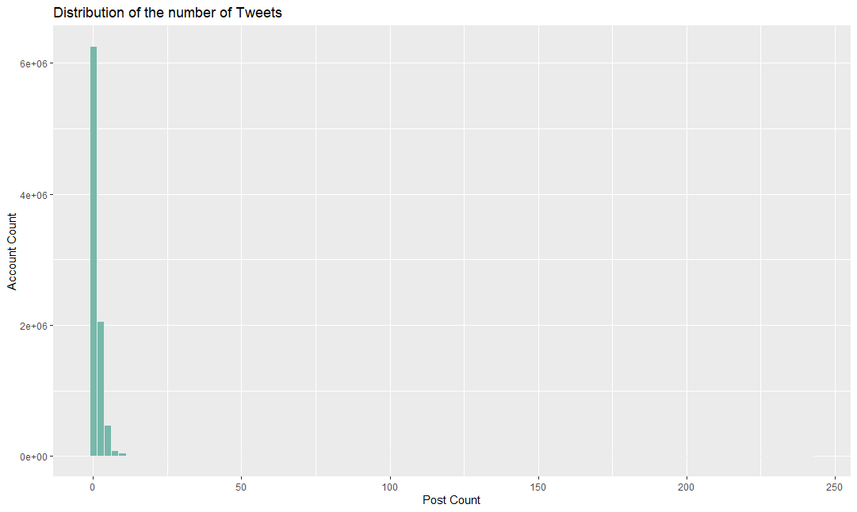

We can see most of the users (Around 6,000,000 users) only post one time. But we also want to see more details of the post count at the right of the graph. We can limit the x and y-axis.

p + coord_cartesian( xlim = c(50,150),ylim = c(0,100))

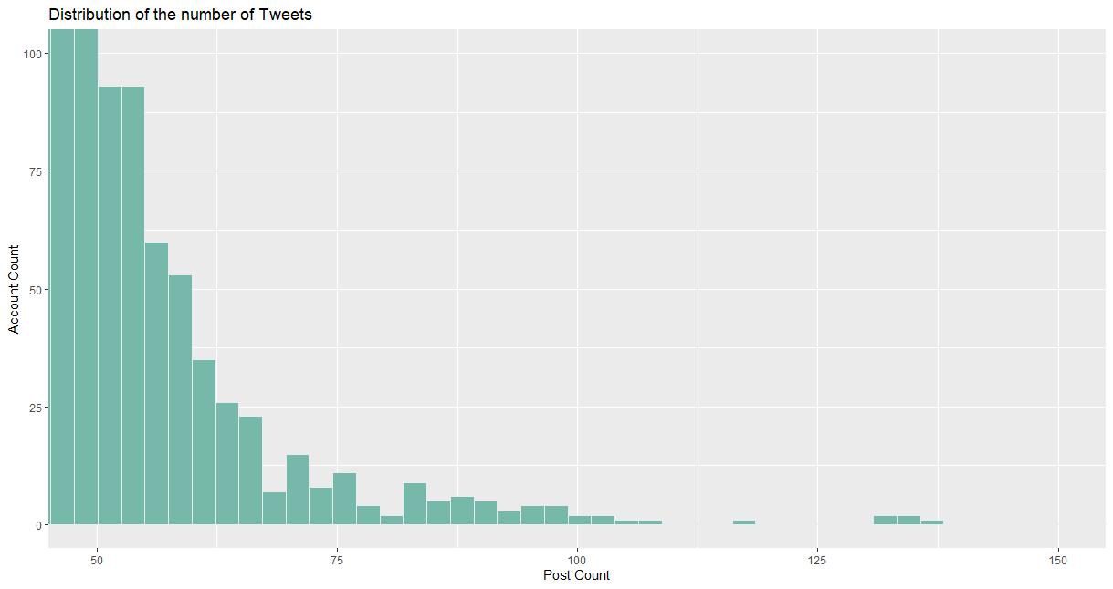

The number of accounts with more than 50 posts is all within 100.

p + coord_cartesian( xlim = c(15,50),ylim = c(100,10000))

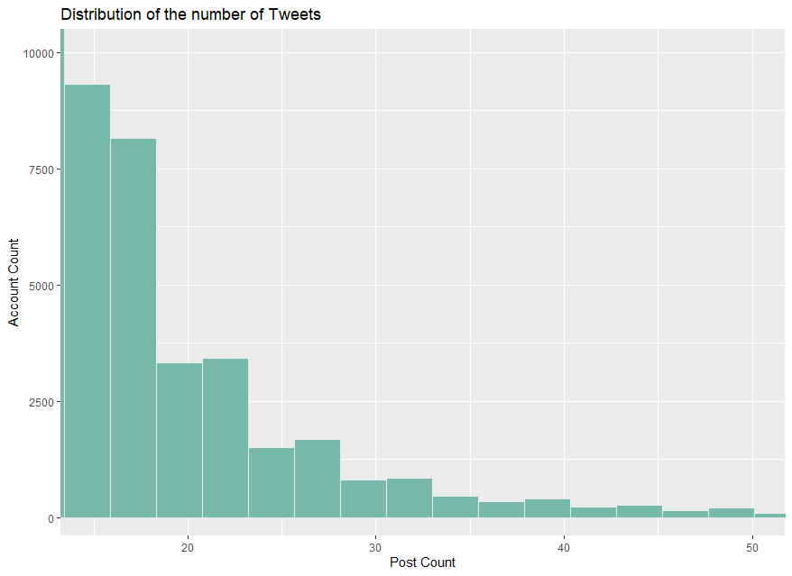

The number of accounts within the range of 15-50 posts is all within 10000.